Incident Lifecycle Automation in ServiceNow
1. Ideation Phase
1.1 Project Title
Incident Lifecycle Automation in ServiceNow
1.2 Project Overview
The project aims to automate and standardize the complete Incident Management lifecycle using ServiceNow. The proposed solution enables Service Desk agents to create, classify, investigate, escalate, resolve, and track incidents while integrating Knowledge Management, Change Management, SLA tracking, and Child Incident Management.
The idea is to establish a structured incident-handling process where an incident can move seamlessly from initial reporting to final resolution while maintaining proper documentation and traceability.
1.3 Problem Statement
Organizations frequently receive IT-related issues such as network failures, VPN authentication problems, hardware issues, and application failures. When these incidents are handled manually or inconsistently, several problems may occur:
- Incorrect or incomplete incident classification.
- Delayed assignment to the appropriate support team.
- Difficulty finding existing solutions.
- Poor visibility into incident progress.
- Lack of proper escalation mechanisms.
- Manual creation and tracking of related change requests.
- Difficulty tracking recurring or related incidents.
- Incomplete cause and resolution documentation.
- Poor SLA compliance.
Therefore, there is a need for an integrated and standardized incident management solution.
1.4 Proposed Idea
The proposed ServiceNow solution automates the incident lifecycle by providing:
- Incident creation through Service Operations Workspace.
- Standardized incident classification.
- Knowledge article recommendations through Agent Assist.
- Assignment and escalation to appropriate support groups.
- Emergency Change Request integration.
- Child Incident creation.
- Cause and resolution documentation.
- Knowledge Article creation from resolved incidents.
- SLA and related-record tracking.
- Multi-team collaboration and incident visibility.
1.5 Project Goals
The major goals of the project are:
- Standardize incident creation and classification.
- Reduce incident resolution time.
- Improve incident assignment and escalation.
- Reuse existing knowledge for faster troubleshooting.
- Integrate Incident and Change Management.
- Track recurring issues using child incidents.
- Maintain proper cause and resolution information.
- Convert useful incident resolutions into Knowledge Articles.
- Improve SLA compliance and service visibility.
- Provide an end-to-end incident lifecycle.

2. Requirement Analysis
2.1 Business Requirements
The system should support the following business requirements:
Requirement | Description
Incident Creation | Service Desk agents should be able to create incidents.
Classification | Incidents should contain appropriate category, subcategory, urgency, service, and CI information.
Knowledge Integration | Agents should be able to search and attach relevant Knowledge Articles.
Assignment | Incidents should be assigned to appropriate support groups.
Escalation | Level 2 teams should be able to investigate and resolve incidents.
Change Integration | Emergency changes should be associated with incidents.
Child Incidents | Related or recurring issues should be tracked through child incidents.
Resolution | Cause, resolution code, and resolution notes should be documented.
Knowledge Creation | Resolved incidents should be converted into Knowledge Articles where appropriate.
SLA Tracking | SLA information should be visible throughout the incident lifecycle.

2.2 Functional Requirements
FR-01: Service Creation
The system should support creation of a service:
- Service: Remote Access
- Operational Status: Operational
FR-02: Service Offering Creation
A service offering should be created under the Remote Access service:
- Service Offering: Corporate VPN
- Parent Service: Remote Access
- Operational Status: Operational
FR-03: Incident Creation
The Service Desk agent should be able to create an incident with:
- Short Description
- Caller
- Assignment Group
- Description
- Channel
- Category
- Subcategory
- Urgency
- Service
- Service Offering
- Configuration Item
FR-04: Incident Classification
The incident should be classified appropriately.
Example:
- Category: Network
- Subcategory: VPN
- Urgency: 2 – Medium
- Service: Remote Access
- Service Offering: Corporate VPN
- Configuration Item: ThinkStationS20
FR-05: Knowledge Integration
Agent Assist should recommend relevant Knowledge Articles based on the incident description.
The agent should be able to:
- View recommended articles.
- Open an article.
- Mark an article as Helpful.
- Attach the article to the incident.
- Add comments regarding the article.
FR-06: Watch List and Work Notes
The system should allow users to be added to:
- Watch List
- Work Notes List
This allows stakeholders to monitor incident progress and updates.
FR-07: Reassignment
The incident should be reassigned from the Service Desk to the appropriate Level 2 support group.
Example:
Service Desk → Network
FR-08: Investigation
The Level 2 Network team should be able to:
- View incident details.
- View Knowledge Articles.
- Review activity.
- View SLA information.
- Take ownership of the incident.
FR-09: Change Integration
When a change is required to resolve the incident, the incident should support creation and tracking of an emergency change request.
The incident can be placed in:
On Hold → Awaiting Change
FR-10: Child Incident
The system should allow creation of child incidents for recurring or related issues.
The child incident should be linked to the parent incident.
FR-11: Cause Documentation
The probable cause of the incident should be documented.
Example:
PowerEdge service was suspended and required restart.
FR-12: Resolution Documentation
The system should record:
- Resolution Code
- Resolution Notes
Example:
- Resolution Code: Workaround provided
- Resolution Notes: Restarted VPN-SRV-02 service as per emergency change request.
FR-13: Knowledge Article Creation
After resolving the incident, the solution should be reusable by creating a Knowledge Article.
Requirements:
- Knowledge Base: IT
- Template: Standard
- Article should contain relevant incident resolution information.
FR-14: SLA Tracking
The system should provide visibility into applicable SLAs through the incident's related records.

3. Project Design Phase
3.1 Solution Architecture
The proposed solution uses ServiceNow's integrated modules to manage the complete incident lifecycle.
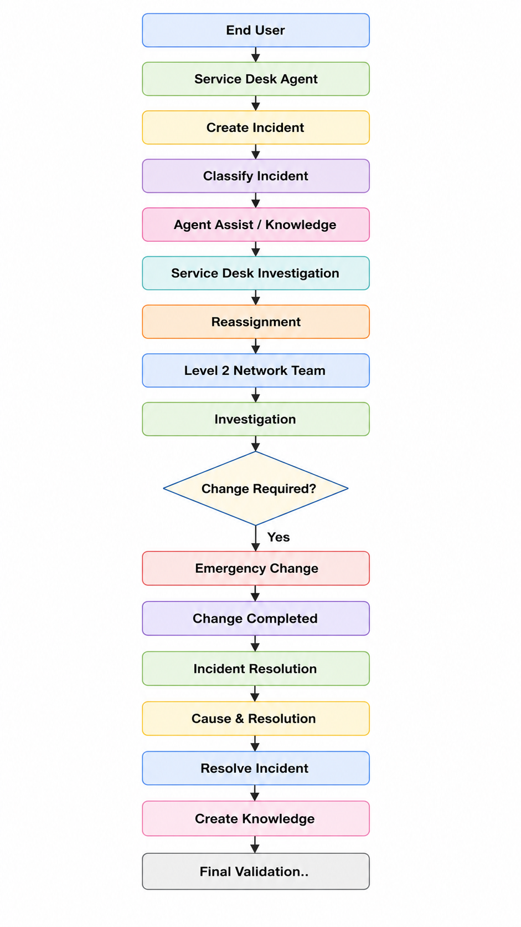
High-Level Flow:
3.2 Service Structure
The service hierarchy is designed as:
Remote Access
│
└── Corporate VPN
Where:
- Remote Access = Parent Service
- Corporate VPN = Service Offering

3.3 Incident Lifecycle Design
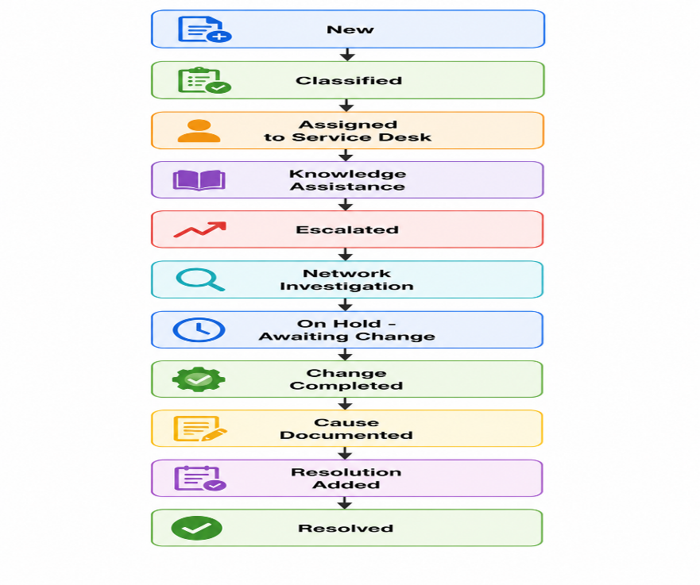
The incident lifecycle is designed as:
3.4 Stakeholder Design
Stakeholder | Role | Expectations | Impact of Automation
End Users | Report IT issues | Quick resolution and visibility | Faster resolution and transparent tracking
Service Desk Agents | First-level support | Easy logging and classification | Standardized intake and faster escalation
Level 2 Support | Diagnose and resolve issues | Complete incident information | Better diagnosis and clear ownership
Change Management Team | Manage emergency changes | Structured change requests | Integrated change control
ServiceNow Administrator | Maintain platform | Scalable and trackable solution | Controlled process management

3.5 Module Integration Design
The project integrates the following ServiceNow capabilities:
- Incident Management
- Knowledge Management
- Agent Assist
- Change Management
- Service Management
- Configuration Management
- SLA Management
- Related Lists
- Child Incidents
4. Project Planning Phase
4.1 Project Execution Roadmap
Project Name: Incident Lifecycle Automation in ServiceNow
The project is planned to automate and standardize the complete incident management lifecycle in ServiceNow. The project activities are divided into milestones covering service configuration, incident creation, classification, knowledge assistance, escalation, change management, resolution, and knowledge creation.
Milestone | Planned Activity
Milestone 1 | Create Service
Milestone 2 | Create Service Offering
Milestone 3 | Create Incident
Milestone 4 | Classify Incident
Milestone 5 | Integrate Knowledge
Milestone 6 | Update Watch List
Milestone 7 | Reassign Incident
Milestone 8 | Level 2 Investigation
Milestone 9 | Create Emergency Change
Milestone 10 | Create Child Incident
Milestone 11 | Add Cause
Milestone 12 | Add Resolution
Milestone 13 | Create Knowledge Article
Milestone 14 | Final Validation
Milestone 15 | Testing and Deployment

4.2 Task Planning
Phase A – Service Configuration
Objective: Configure the required service and service offering for the incident.
- Create Remote Access service.
- Set the operational status.
- Create Corporate VPN service offering.
- Associate the offering with Remote Access.
Deliverable: Remote Access service with Corporate VPN service offering.
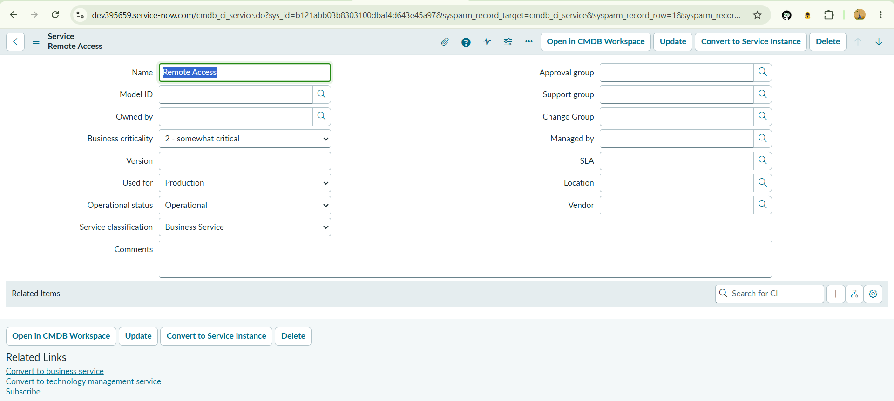
Phase B – Incident Management
Objective: Create and classify a VPN-related incident.
- Impersonate Service Desk user.
- Create a VPN incident.
- Add caller and short description.
- Assign the incident to Service Desk.
- Update incident details.
- Select Network → VPN category.
- Set urgency and priority.
- Associate service, service offering, and CI.
Deliverable: Properly created and classified VPN incident.
Phase C – Knowledge Management
Objective: Use existing knowledge to assist in resolving the incident.
- Open Agent Assist.
- Search for relevant VPN Knowledge Articles.
- Open the appropriate article.
- Mark the article as Helpful.
- Attach the article to the incident.
- Add relevant comments.
Deliverable: Relevant Knowledge Article attached to the incident.
Phase D – Collaboration and Escalation
Objective: Collaborate with stakeholders and escalate the incident to the appropriate support team.
- Add stakeholder to the Watch List.
- Add user to the Work Notes List.
- Reassign the incident to Network Support.
- Verify the Assigned To field.
- Impersonate Level 2 Technician.
- Assign the incident to the technician.
- Verify incident and SLA information.
Deliverable: Incident successfully escalated to Level 2 support.
Phase E – Change and Child Incident Management
Objective: Manage additional work required to resolve the incident.
- Update the Configuration Item.
- Set the incident to On Hold.
- Select Awaiting Change.
- Create and link an Emergency Change.
- Create a Child Incident.
- Verify the parent-child relationship.
Deliverable: Emergency change and child incident linked to the parent incident.
Phase F – Resolution
Objective: Document the cause and resolution and complete the incident.
- Add the probable cause.
- Add the resolution code.
- Add resolution notes.
- Resolve the parent incident.
- Verify the child incident status.
- Verify the change request relationship.
Deliverable: Incident resolved with complete resolution information.
Phase G – Knowledge Creation
Objective: Create reusable knowledge based on the incident resolution.
- Select Create Knowledge.
- Select IT Knowledge Base.
- Select Standard template.
- Verify the article information.
- Save the Knowledge Article.
- Verify the article under Related Records.
Deliverable: New Knowledge Article created from the incident resolution.
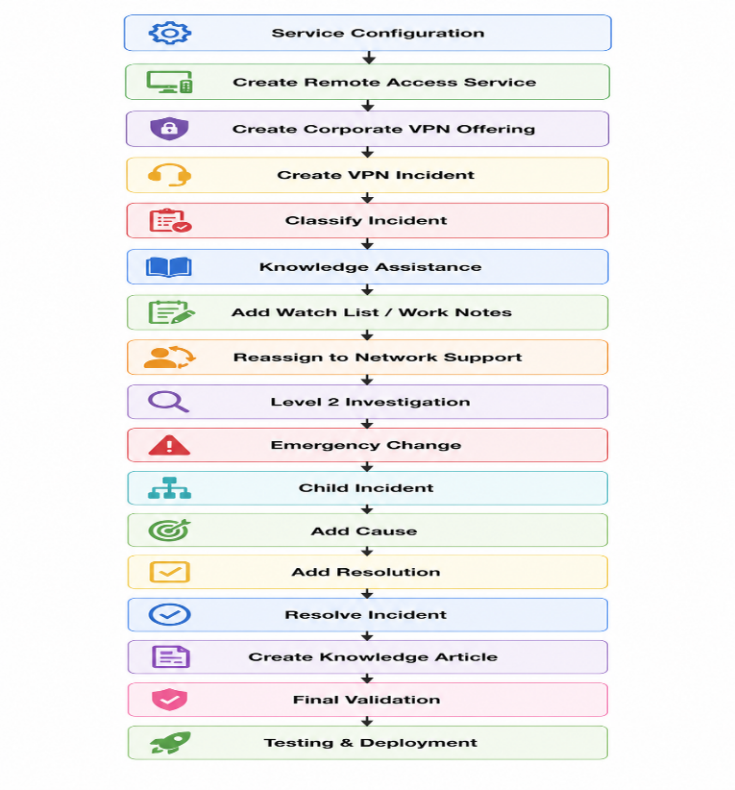
4.3 Project Workflow

4.4 Project Deliverables
Phase | Deliverable
Service Configuration | Remote Access Service and Corporate VPN Offering
Incident Management | Created and classified VPN Incident
Knowledge Management | Knowledge Article attached to Incident
Collaboration & Escalation | Incident assigned to Level 2 Network Support
Change Management | Emergency Change linked to Incident
Child Incident Management | Parent-Child Incident relationship
Resolution | Cause and Resolution details
Knowledge Creation | New IT Knowledge Article
Final Phase | Validated and tested project
4.5 Expected Project Outcome
At the end of the project, the Incident Lifecycle Automation in ServiceNow will demonstrate the complete incident management process from service configuration and incident creation to classification, knowledge assistance, escalation, change management, resolution, and knowledge creation. This ensures that incidents are handled in a structured and traceable manner.

5. Project Development Phase
This phase contains the actual implementation activities performed in ServiceNow.
5.1 Service Configuration
Step 1: Create Service
Navigate to:
All → cmdb_ci_service.list → New
Enter:
Field | Value
Name | Remote Access
Operational Status | Operational

Submit the record.
Step 2: Create Service Offering
Navigate to:
All → service_offering.list → New
Enter:
Field | Value
Name | Corporate VPN
Parent | Remote Access
Operational Status | Operational
Submit the record.
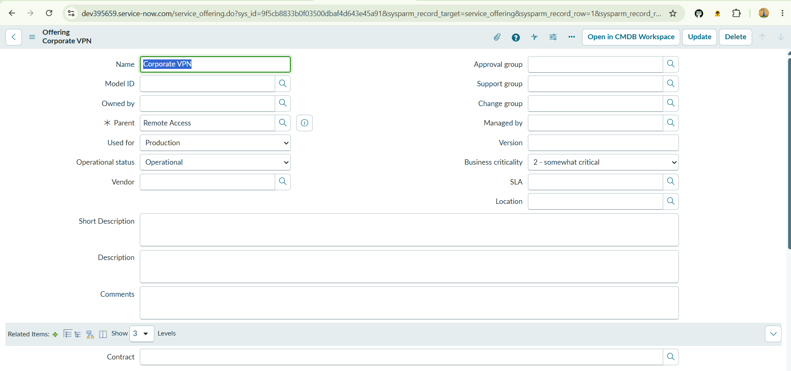
5.2 Incident Creation
Navigate to:
Service Operations Workspace → List → Incidents → Open → New
Create an incident with:
Field | Value
Short Description | Unable to connect to Corporate VPN from home office
Caller | Michael Hoefer
Assignment Group | Service Desk
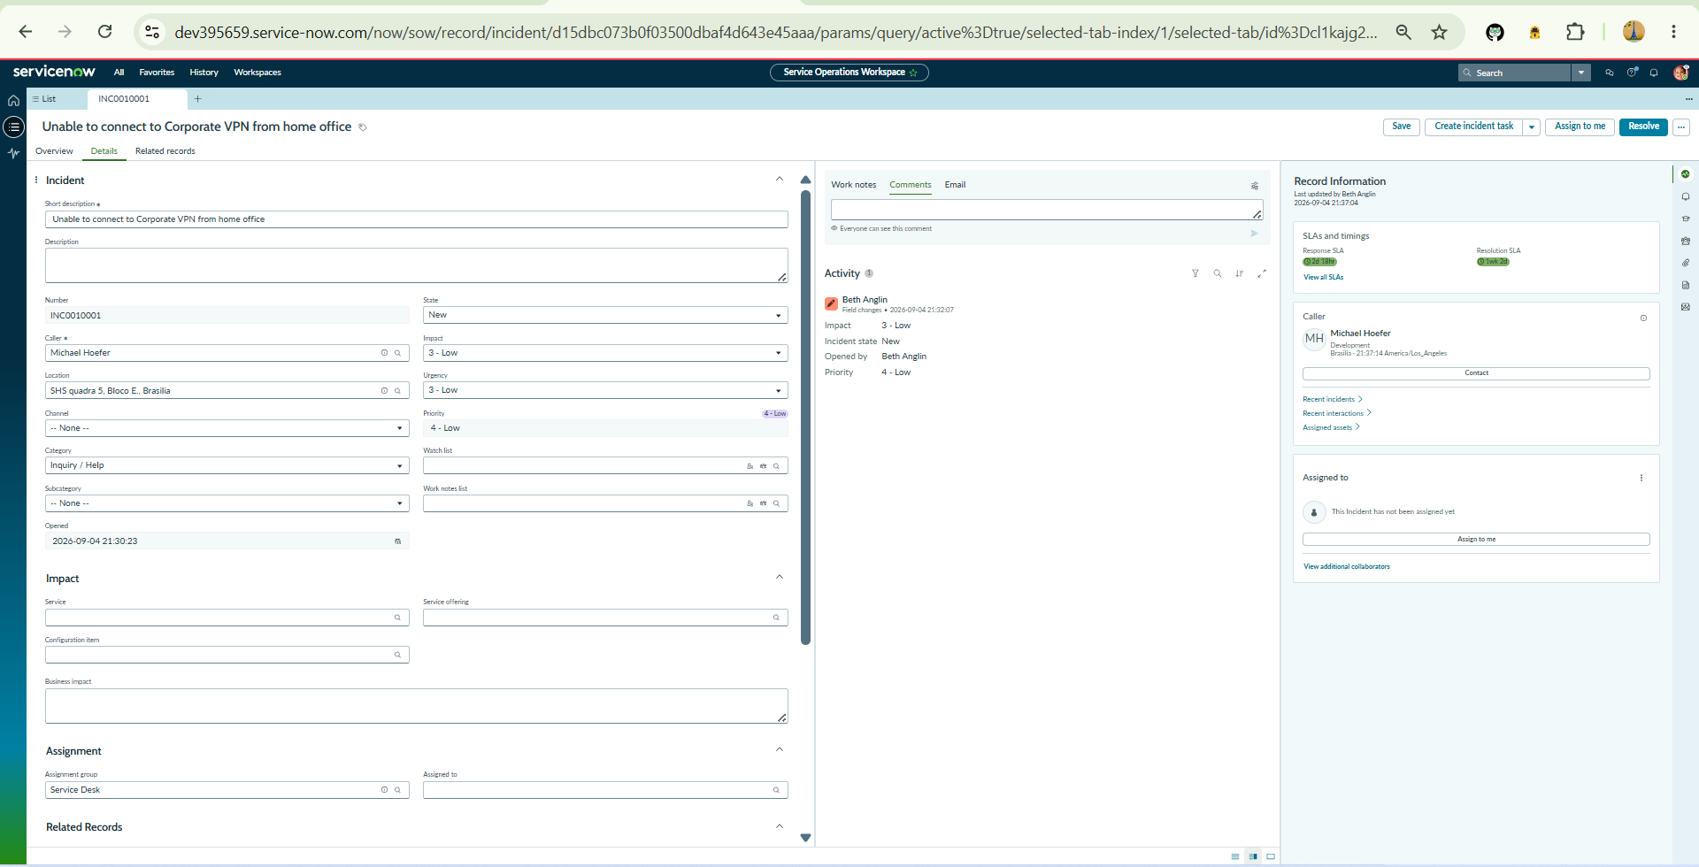
Save the incident.

5.3 Incident Classification
Update the incident with:
Field | Value
Description | Michael advised he was able to connect yesterday evening, but this morning received an authentication error. The Internet works fine.
Channel | Phone
Category | Network
Subcategory | VPN
Urgency | 2 – Medium
Service | Remote Access
Service Offering | Corporate VPN
Configuration Item | ThinkStationS20
Add the following work note:
Classified and assigned incident.
Then select Assign to me and save.
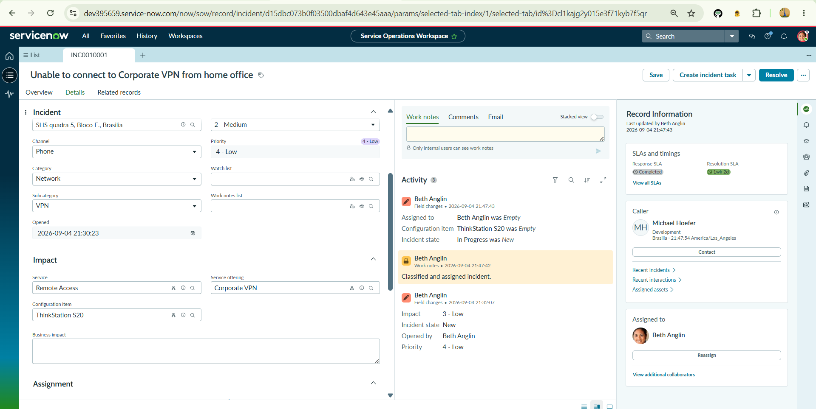
5.4 Agent Assist Implementation
Open Agent Assist from the right-side panel.
Verify that relevant Knowledge Articles are displayed based on the incident's short description.
Perform the following:
- Open a relevant Knowledge Article.
- Select the three-dot menu.
- Mark the article as Helpful.
- Select Attach Article.
- Add the comment:
Follow the steps and resolve the incident.
- Attach the article.
- Return to the incident.
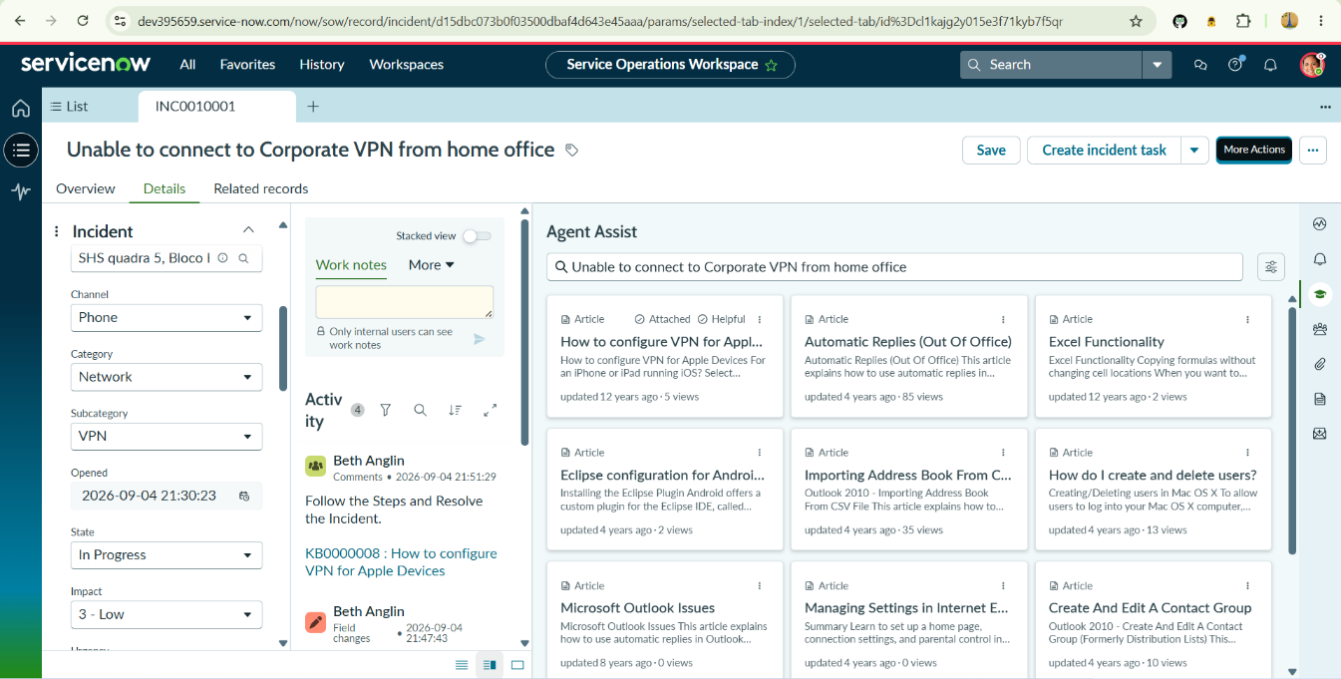
- Verify that the article is recorded in the Activity log.
5.5 Watch List Configuration
In the incident Details tab:
- Add Samantha Bordwell to Watch List.
- Add Beth Anglin to Work Notes List.
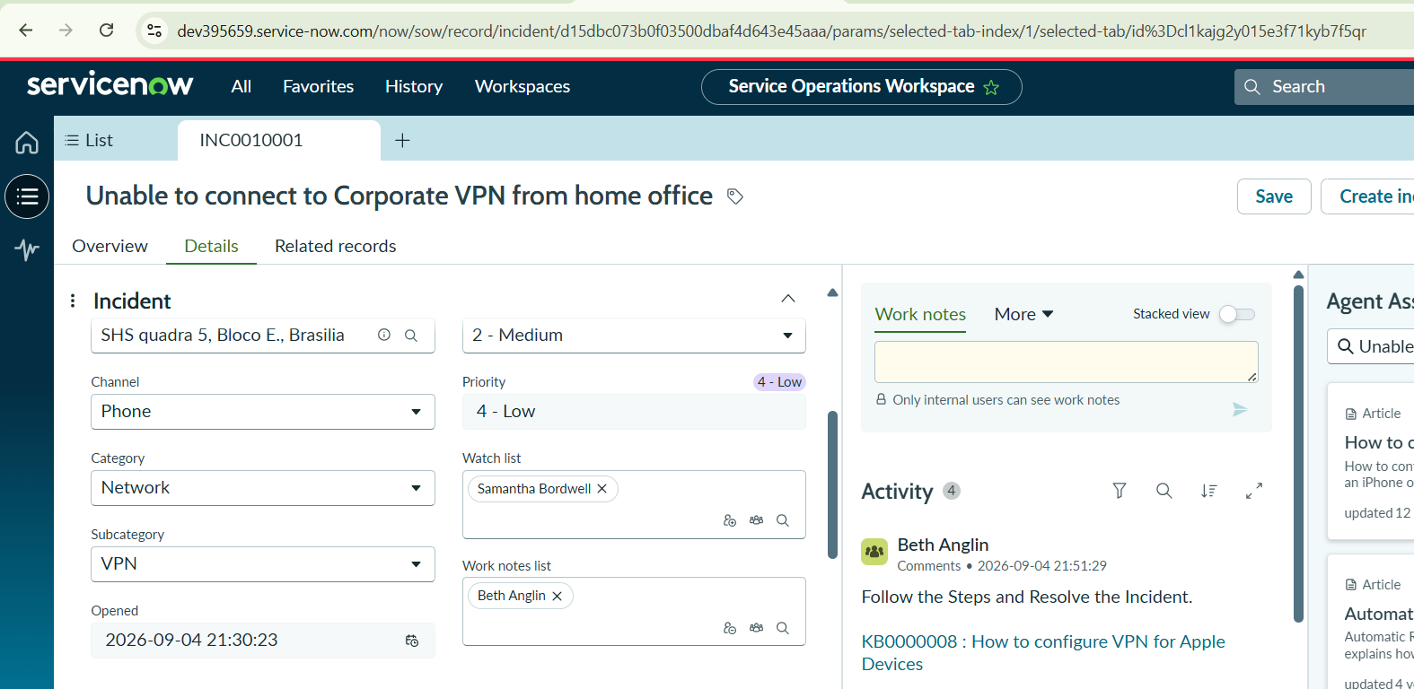
This ensures that relevant stakeholders receive updates and can monitor the incident.
5.6 Incident Reassignment
Update:
Assignment Group → Network
Verify that the Assigned To field is cleared automatically when the assignment group changes.
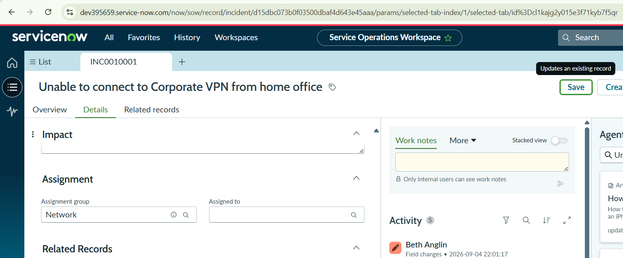
Save the incident.

5.7 Level 2 Investigation
Impersonate the Level 2 Network technician.
Navigate to:
Service Operations Workspace → Incidents → Open
Open the VPN incident.
Select Assign to me.
Verify:
- Incident description is available.
- Knowledge Articles are available.
- SLA information is visible.
- Task SLAs appear in Related Records.
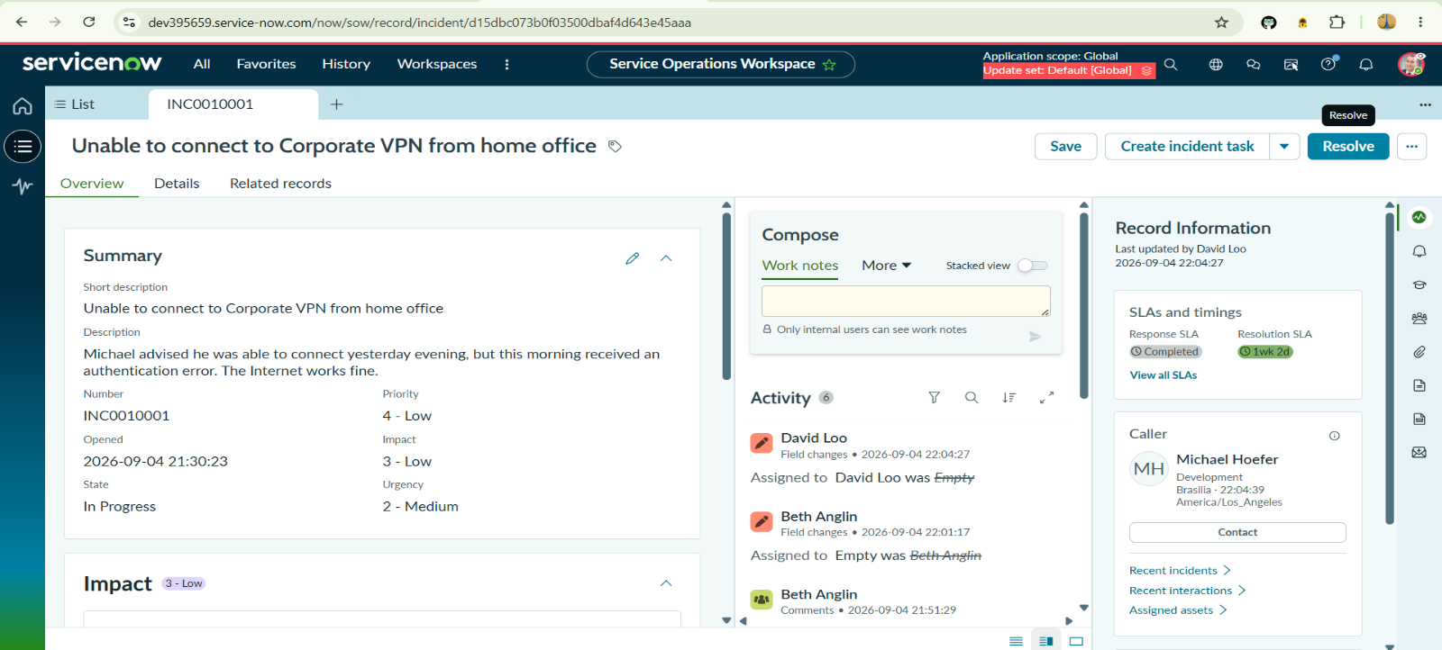
- Incident information is accessible to the Network team.

5.8 Emergency Change Integration
Update the Configuration Item as required.
Place the incident in:
State: On Hold
On Hold Reason: Awaiting Change
Create or associate the required emergency change request with the incident.
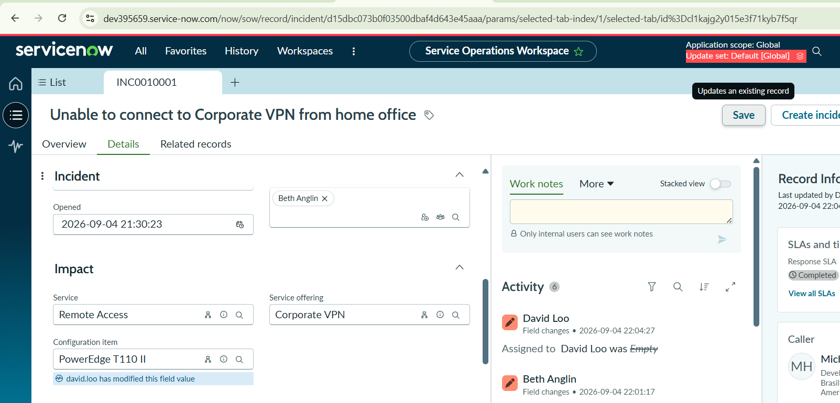
The change request provides controlled implementation of the technical fix while maintaining traceability between the incident and change.
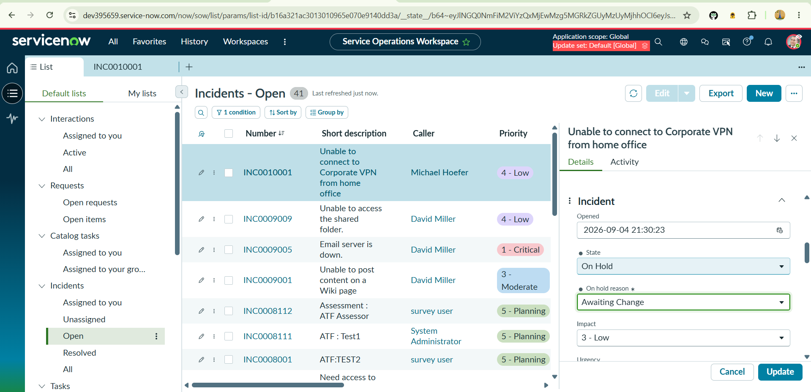
5.9 Child Incident Creation
Navigate to:
Related Records → Child Incidents → New
Enter:
Field | Value
Short Description | Unable to connect to Corporate VPN
Caller | Any available user
Description | User receiving VPN authentication failure error
Save the record.
Record the child incident number.
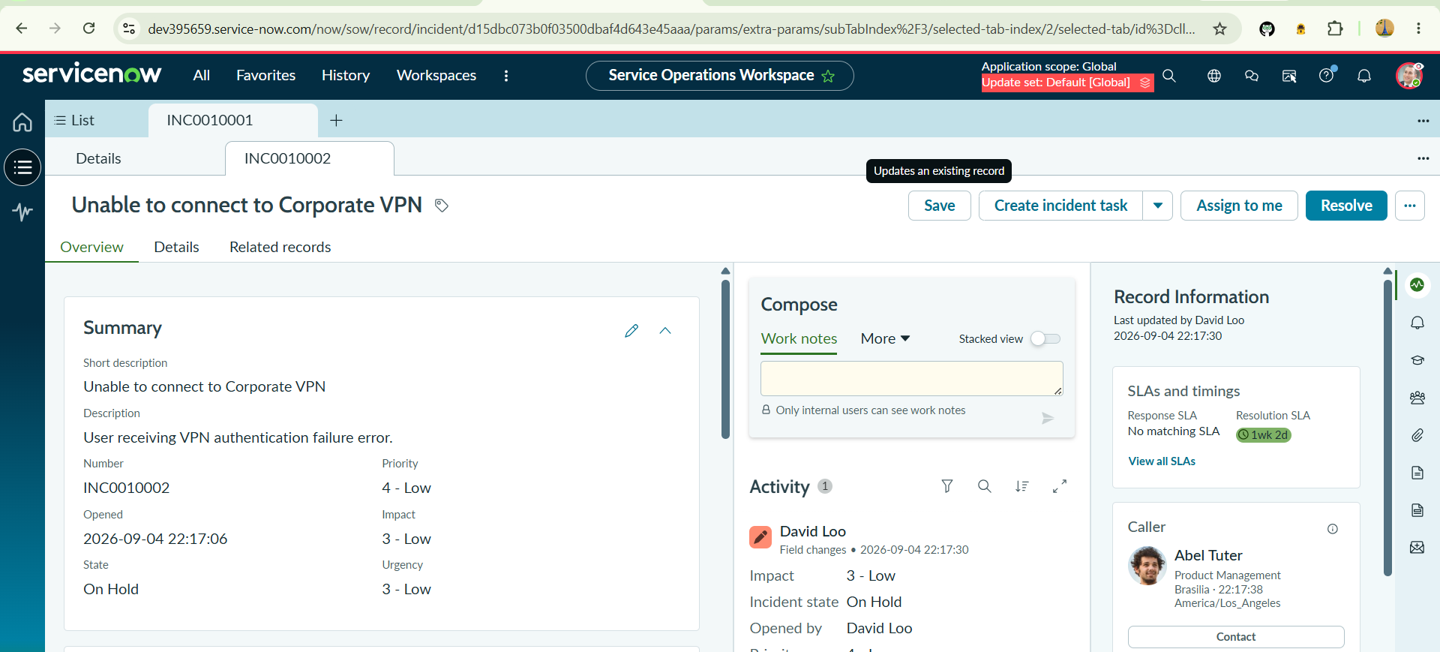
Return to the parent incident and verify that the child incident appears under Related Records.

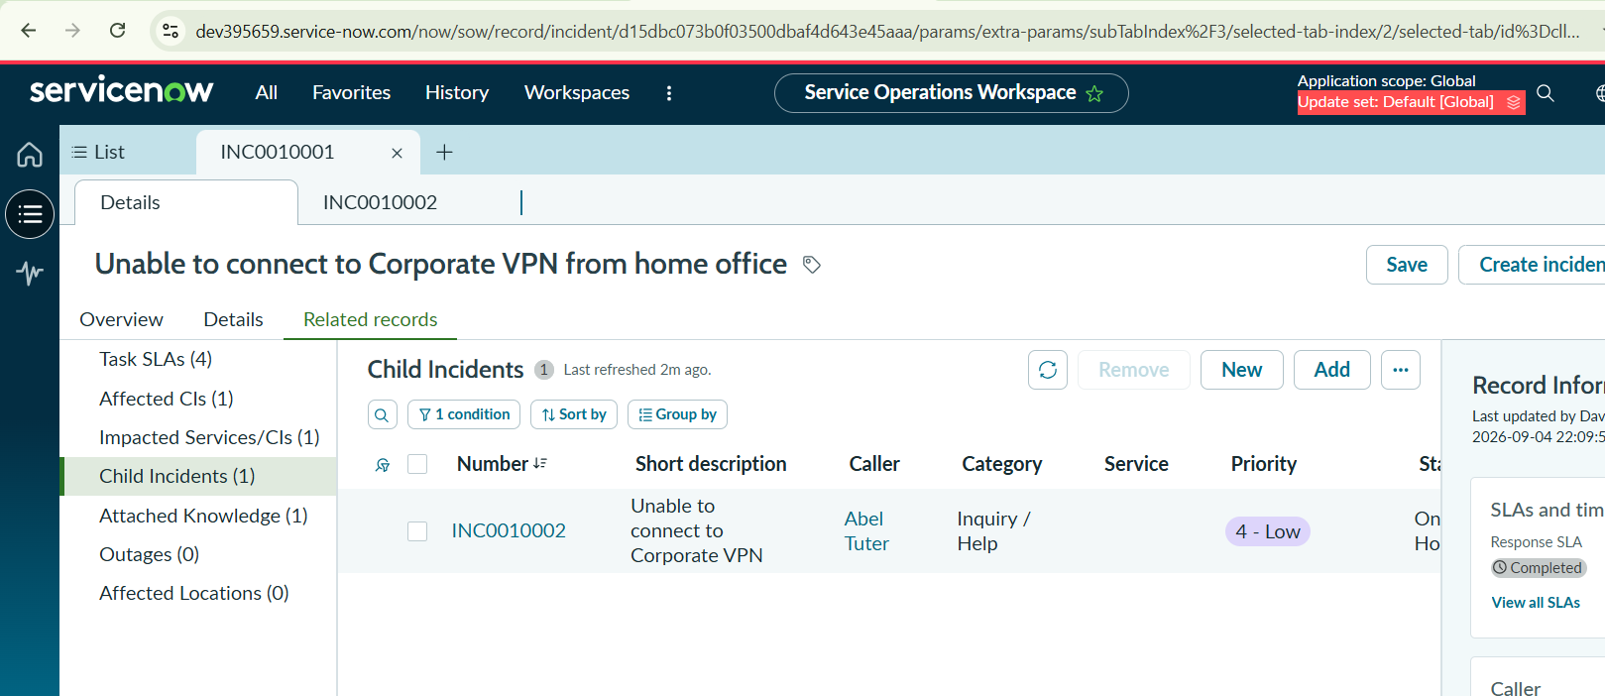
5.10 Cause Documentation
From the Overview tab, select Add Cause.
Enter:
Probable Cause:
PowerEdge service was suspended and required restart.
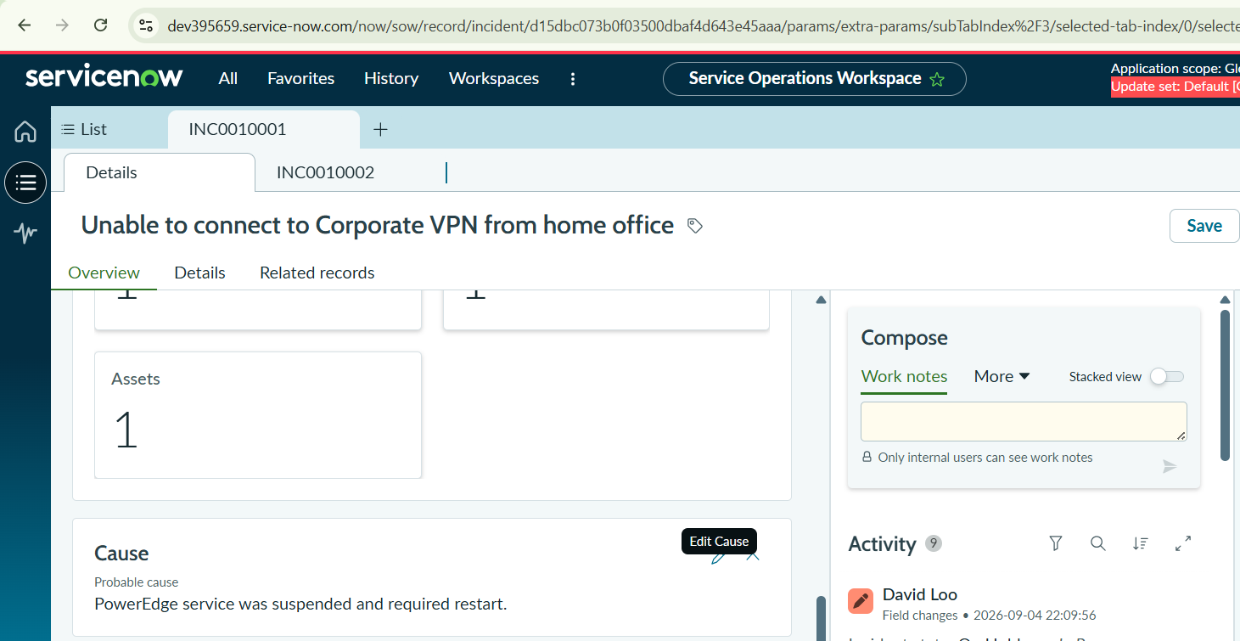
Save the cause information.

5.11 Resolution Documentation
Select Add Resolution.
Enter:
Field | Value
Resolution Code | Workaround provided
Resolution Notes | Restarted VPN-SRV-02 service as per emergency change request.
Save the resolution.
Select Resolve and confirm the resolution.
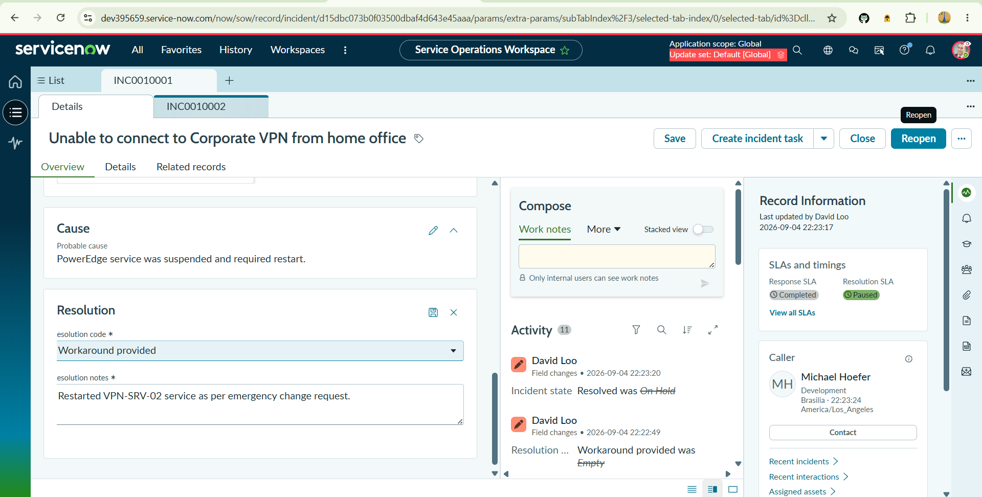
5.12 Knowledge Article Creation
After resolving the incident, select Create Knowledge.
Configure:
Field | Value
Knowledge Base | IT
Article Template | Standard
Select Next.
Verify the incident and resolution details.
Save the Knowledge Article.
Return to the parent incident and navigate to:
Related Records → Knowledge
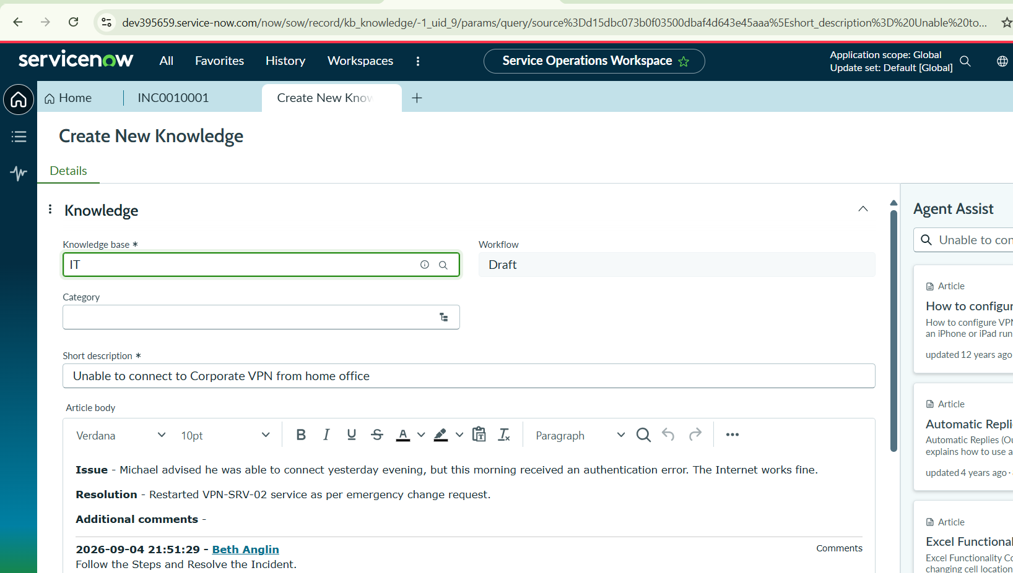
Verify that the newly created Knowledge Article is linked to the incident.
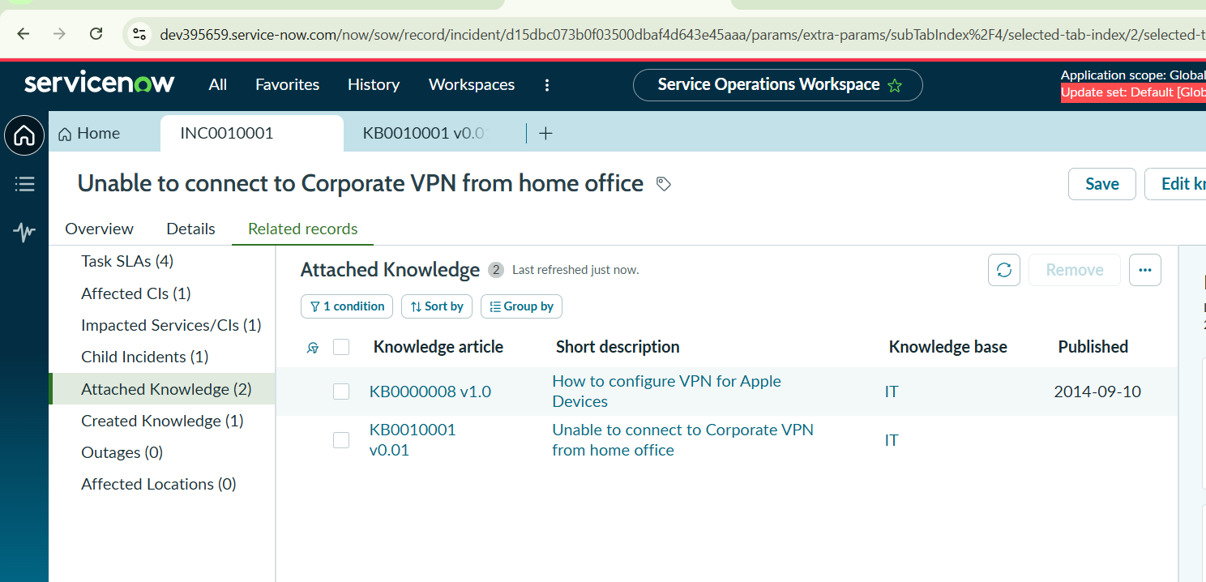
5.13 Testing and Validation
The implemented solution should be tested against the complete incident lifecycle.
Test Case 1 – Incident Creation
Expected Result:
Incident should be successfully created with caller and short description.
Test Case 2 – Classification
Expected Result:
Category, subcategory, urgency, service, service offering, and CI should be correctly populated.
Test Case 3 – Knowledge Integration
Expected Result:
Relevant Knowledge Articles should appear in Agent Assist and should be attachable to the incident.
Test Case 4 – Reassignment
Expected Result:
Incident should move from Service Desk to Network support.
Test Case 5 – SLA
Expected Result:
Applicable SLA should be visible under Task SLAs.
Test Case 6 – Change Integration
Expected Result:
Emergency Change Request should be linked to the incident.
Test Case 7 – Child Incident
Expected Result:
Child incident should be created and displayed under the parent incident.
Test Case 8 – Resolution
Expected Result:
Cause and resolution information should be recorded and the incident should move to Resolved.
Test Case 9 – Knowledge Creation
Expected Result:
A Knowledge Article should be created from the resolved incident and linked to it.
5.14 Final Validation Checklist
At the end of development and testing, verify:
- ☑ Parent incident is Resolved.
- ☑ Child incident is Resolved.
- ☑ Incident activity contains the resolution information.
- ☑ Change Request is linked.
- ☑ Knowledge Article is created.
- ☑ Knowledge Article is linked to the incident.
- ☑ SLA tracking is visible.
- ☑ Assignment and reassignment work correctly.
- ☑ Incident classification is accurate.
- ☑ Watch List and Work Notes List are populated.
- ☑ Parent-child incident relationship is maintained.
- ☑ Complete incident history is available.

